ZABBIX
I. Introduction
1.1.Overview
1.1.1.What is zabbix and how it monitor
- Zabbix is an enterprise-class open source distributed monitoring solution.
- Zabbix is a software that monitors numerous parameters of a network and the health and integrity of servers, virtual machines, applications, services, databases, websites, the cloud and more.
- Zabbix uses a flexible notification mechanism that allows users to configure e-mail based alerts for virtually any event. This allows a fast reaction to server problems

What is Zabbix monitoring :
- Network monitoring
+ Network performance
+ Network health
+ Configuration changes
- Server monitoring
+ Server performance
+ Server availability
+ Configuration changes
- Cloud monitoring
  - Google apps,Amazon WebService,Google clouds,…
- Application monitoring
  - Gitlab,Microsoft IIS,…
- Service monitoring
  - Git,Active Directory,Nginx,…

1.2. Components
1.2.1. Zabbix Components
- Zabbix consists of several major software components, the responsibilities of which are outlined below :
+ Zabbix Server
-This is the centre of the Zabbix software
-The Server can remotely check networked services (such as web servers and mail servers) using simple service checks, but it is also the central component to which the Agents will report availability and integrity information and statistics
-The Server is the central repository in which all configuration, statistical and operational data are stored, and it is the entity in the Zabbix software that will actively alert administrators when problems arise in any of the monitored systems.

+ Zabbix Proxy
-The Proxy is an optional part of Zabbix deployment. The Proxy collects performance and availability data on behalf of Zabbix Server. All collected data is buffered locally and transferred to Zabbix Server the Proxy belongs to.
-Zabbix Proxy is an ideal solution for a centralized monitoring of remote locations, branches, networks having no local administrators.
-Zabbix Proxies can also be used to distribute load of a single Zabbix Server. In this case, only Proxies collect data thus making processing on the Server less CPU and disk I/O hungry.

+ Zabbix Agent
- In order to actively monitor local resources and applications (such as harddrives, memory, processor statistics etc.) on networked systems, those systems must run the Zabbix Agent.
- The Agent will gather operational information from the system on which it is running, and report these data to the Zabbix for further processing.
- In case of failures (such as a harddisk running full, or a crashed service process), the Zabbix Server can actively alert the administrators of the particular machine that reported the failure.
- The Zabbix Agents are extremely efficient because of use of native system calls for gathering statistical information.

+ The Web Interface
- In order to allow easy access to the monitoring data and the configuration of Zabbix from anywhere and from any platform, the Web-based Interface is provided.
- The Interface is a part of the Zabbix Server, and is usually (but not necessarily) run on the same physical machine as the one running the Zabbix Server.

1.3.Operation
1.3.1. Sending message
- Sending a message is one of the best ways of notifying people about a problem. That is why it is one of the primary actions offered by Zabbix.
- To successfully receive and read e-mails from Zabbix, e-mail servers/clients must support standard 'SMTP/MIME e-mail' format since Zabbix sends UTF-8 data (If the subject contains ASCII characters only, it is not UTF-8 encoded.).

- The subject and the body of the message are base64-encoded to follow 'SMTP/MIME e-mail' format standard.
- View the status of messages sent in Monitoring → Problems
1.3.2.Romote commands
- With remote commands you can define that a certain pre-defined command is automatically executed on the monitored host upon some condition.
=> Thus remote commands are a powerful mechanism for smart pro-active monitoring.
1.3.3. Additional Operations
- Can define the following operations for all events:
- send a message
- execute a remote command
- add host
- remove host
- enable host
- disable host
- add to host group
- remove from host group
- link to template
- unlink from template
- set host inventory mode
1.3.3. Using macro in messages
- In message subjects and message text you can use macros for more efficient problem reporting.
1.3.4. Recovery operations
- Recovery operations allow you to be notified when problems are resolved
- Both messages and remote commands are supported in recovery operations
- While several operations can be added, escalation is not supported - all operations are assigned to a single step and therefore will be performed simultaneously.

II. Implementation
2.1.Topology

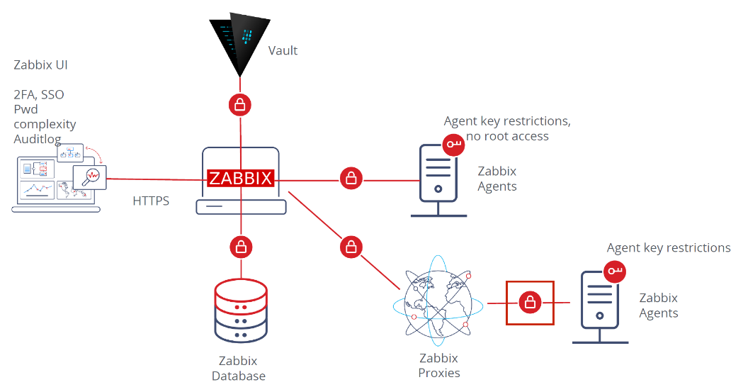
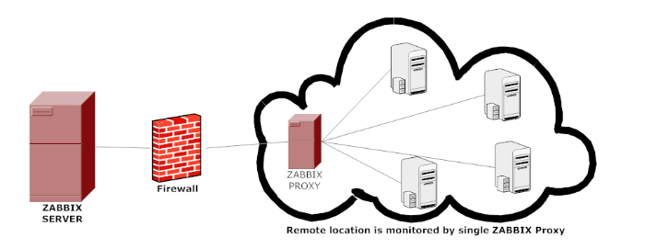

Zabbix is 100% Enterprise-ready
Unlimited scalability ( Khả năng mở rộng không giới hạn )
- From monitoring smart home to multi-tenant enterprise environments - Zabbix is scalable to any infrastructure
( Từ giám sát ngôi nhà thông minh đến môi trường doanh nghiệp nhiều người thuê - Zabbix có thể mở rộng cho bất kỳ cơ sở hạ tầng nào )

Distributed monitoring ( Giám sát phân tán )
- Deploy and scale a distributed Zabbix infrastructure from a central Web UI with native encryption support between all of the components
( Triển khai và mở rộng cơ sở hạ tầng Zabbix phân tán từ giao diện người dùng Web trung tâm với hỗ trợ mã hóa gốc giữa tất cả các thành phần )

Secured and safe
- Keep sensitive information secure by storing it in an external vault

High availability ( Tính khả dụng cao )
- Ensure 24/7 uptime and negate the risk of data loss for Zabbix infrastructure with Zabbix high availability solution
( Đảm bảo thời gian hoạt động 24/7 và loại bỏ nguy cơ mất dữ liệu cho cơ sở hạ tầng Zabbix với giải pháp tính khả dụng cao của Zabbix )

Flexible ( linh hoạt )
- Monitor whatever we want - Zabbix comes with many different ways to collect data, transform it, analyze and visualize it
( Theo dõi bất cứ điều gì chúng ta muốn - Zabbix có nhiều cách khác nhau để thu thập dữ liệu, chuyển đổi dữ liệu, phân tích và trực quan hóa dữ liệu )
Set up Server

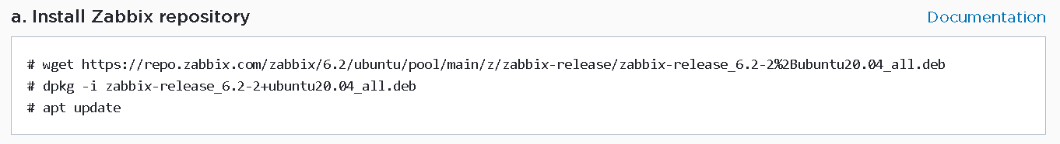

Download sql-server :
Apt install mysql-server

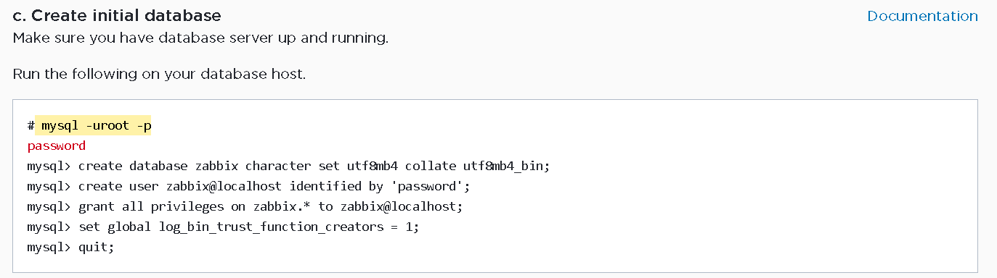
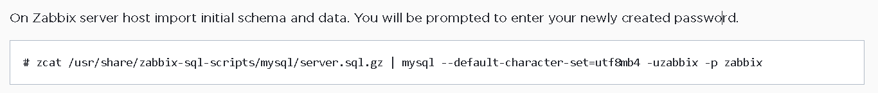

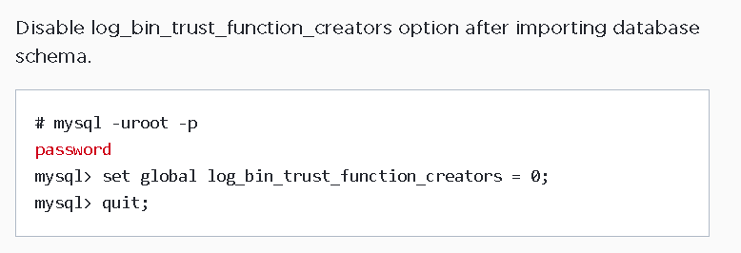
()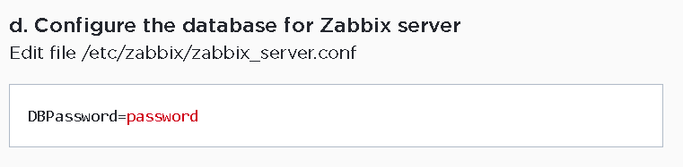
(nano)
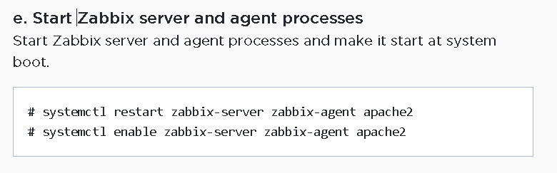

Check server status :
Systemctl status aphache2

Visit zabbix-server’s website : 127.0.0.1/zabbix/
USING ZABBIX TO MONITORING
Configuration -> Hosts

